Web Portal Evolution/Research

## Context

* Adoption/retention is the main goal of the new version of Agnes. *How might we support the relaunch?*
* Previous user research has shown that student org leaders prefer to work while on their desktop. *How might we support the work student leaders do?*
* Currently, Agnes’ main function (event curation) is populated by pulling from various online sources and user generated content is also important. *How might we encourage user event creation?*

## Initial idea (pre-research) - The web portal/dashboard for student leaders

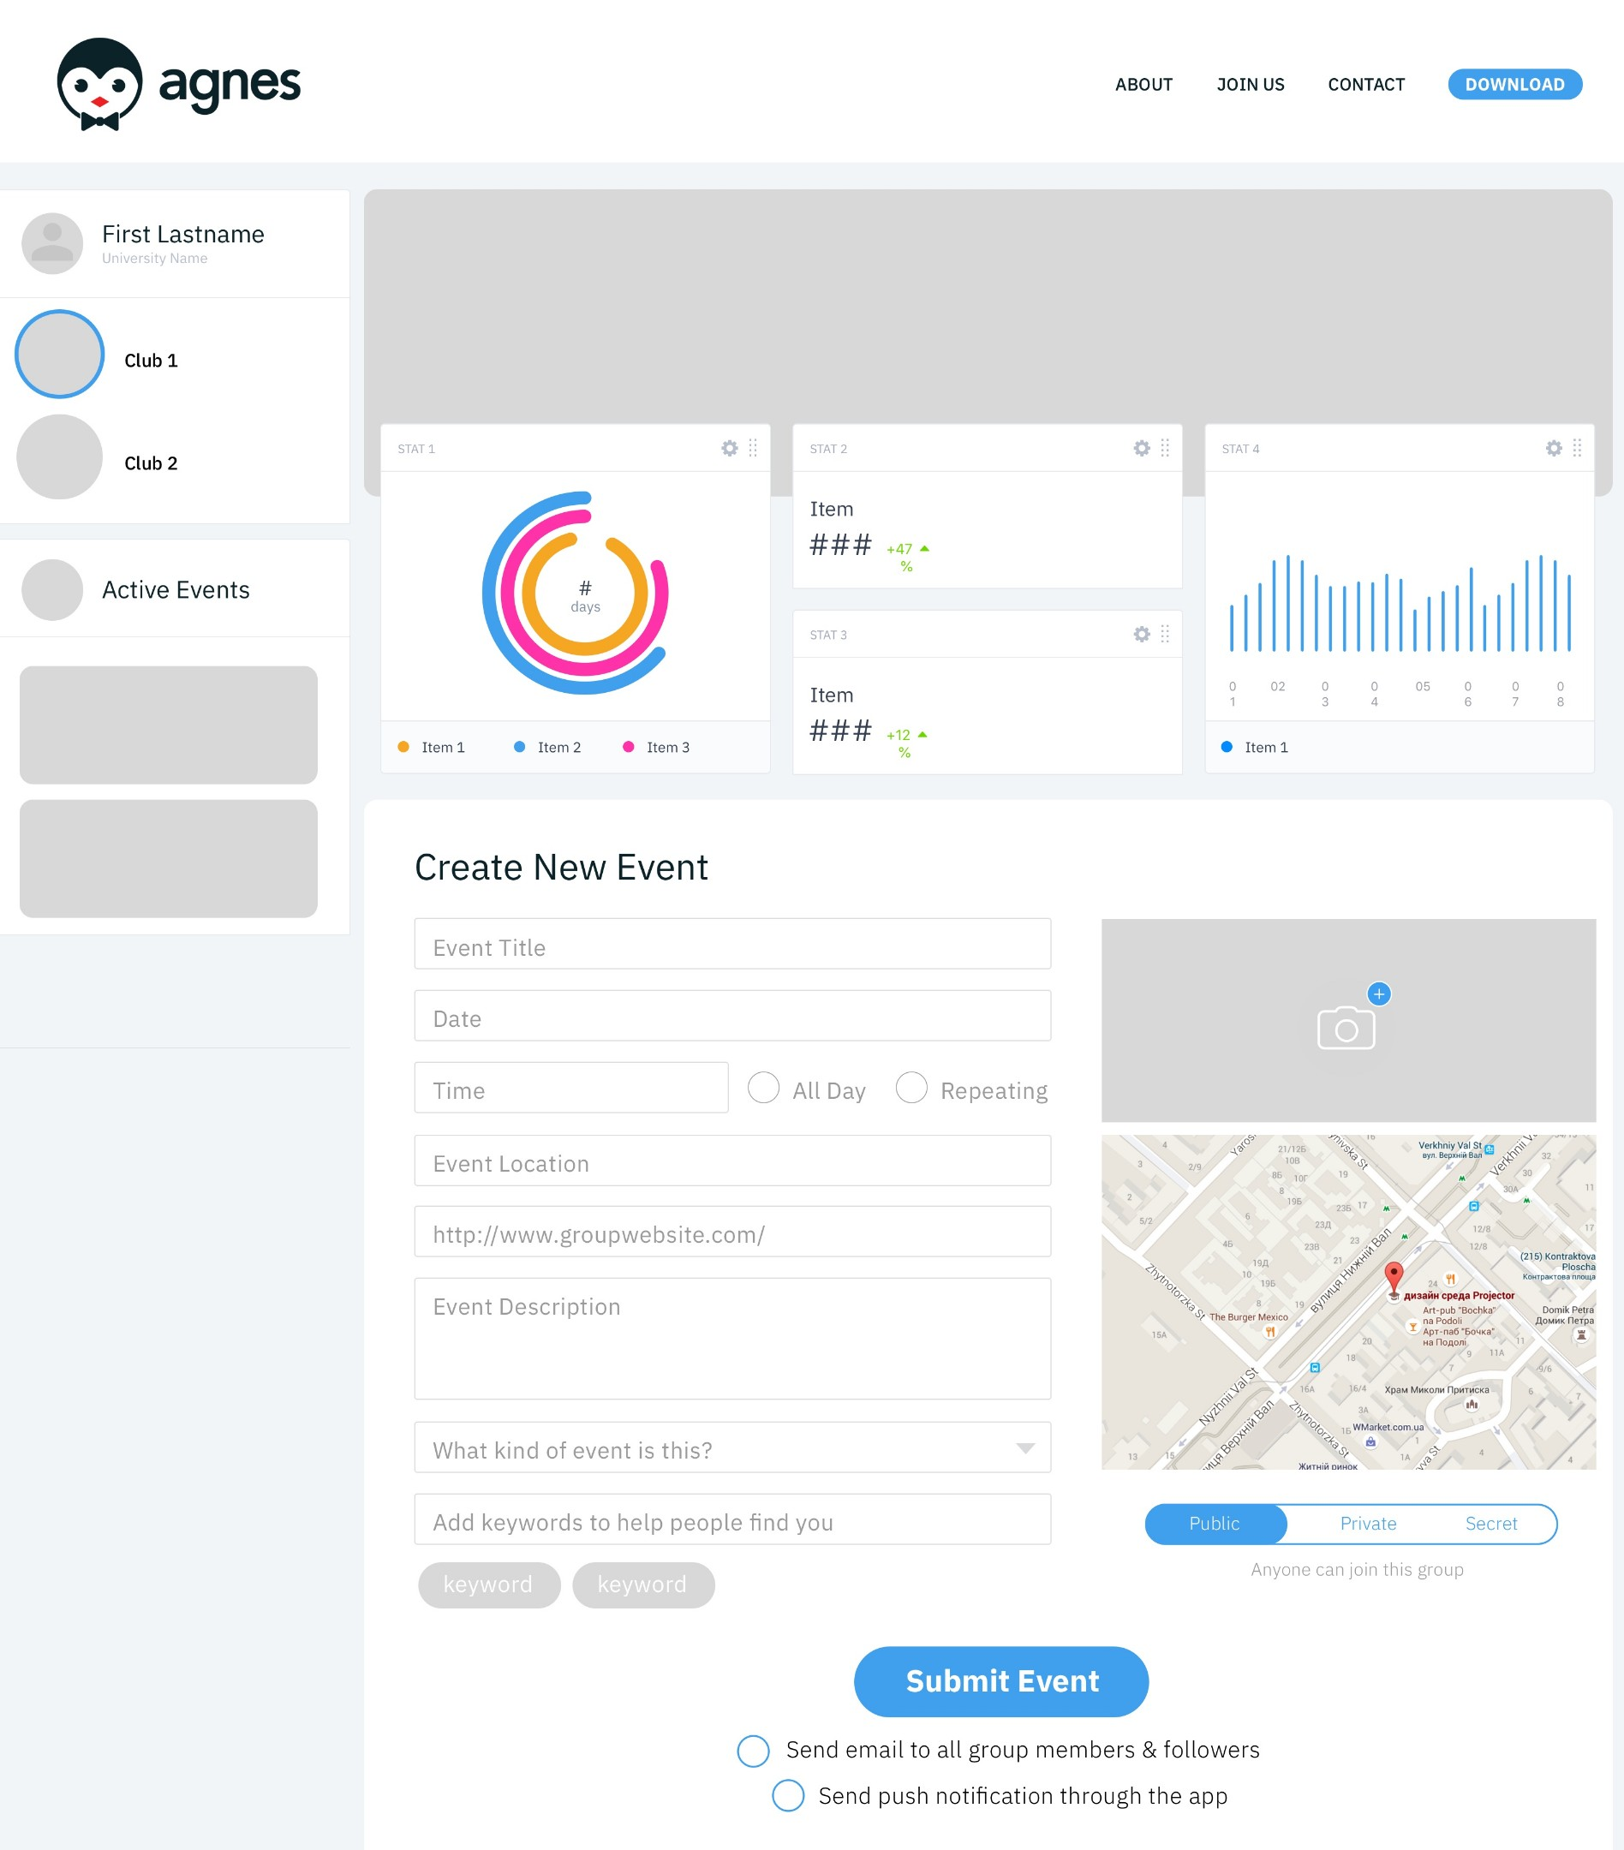

Dashboard mockup by Laila

The initial idea was an Agnes dashboard for student leaders. Leaders would be able to add their events to the app.

* These events would also be communicated through email (functionally like a listserv, since a large majority of clubs already use email - found through past research) - Recipients could then interact with these emails.

Being synced to the app, this would also be the place to manage the group (e.g. updating information and group status from a computer rather than phone).

* Note: While we went into the research process with this initial idea in mind, we took deliberate effort to force ourselves to start from scratch. Only in this way could the process of uncovering pain points be done in a thorough and unbiased way. That being said, inevitably there was some amount of bias that crept into our research. This documentation serves to convey our process - as objectively as possible - from beginning to end.

## User Research + Initial Group Profile

Before building anything new, we sought to understand the overall problems of student organization leaders.

The interviews were framed with the following general questions in mind:

* What is the process of running their group from the beginning of the semester to the end?
* What were the main concerns as these students lead their group throughout the entire semester?
* How did they approach their group’s events (if we want to build on what we have with the app)?
* Most importantly, what kind of tools would be most useful for student organization leaders?

We asked general questions in order to get honest answers about their top-of-mind concerns. We [talked to **6 student leaders**](https://docs.google.com/document/d/1GyGmm2ahaO5xvnVrbxQDuww8MWyL9ZUE22UJb4xo0rw/edit) from various organizations (e.g. sports, cultural, professional, etc.)

These were their main concerns:

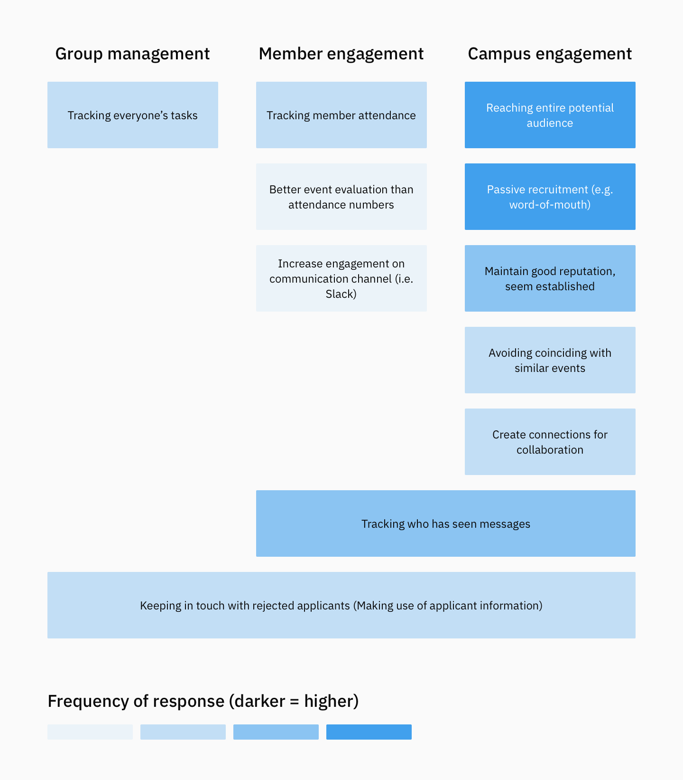

Beyond learning about our opportunity areas (mainly in campus engagement), we also got a sense of the types of leaders who would most benefit from and be most open to new tools. Personality of the leaders matter as do the the cultures of the groups on campus - we began referring to this idea as their leadership motivation.

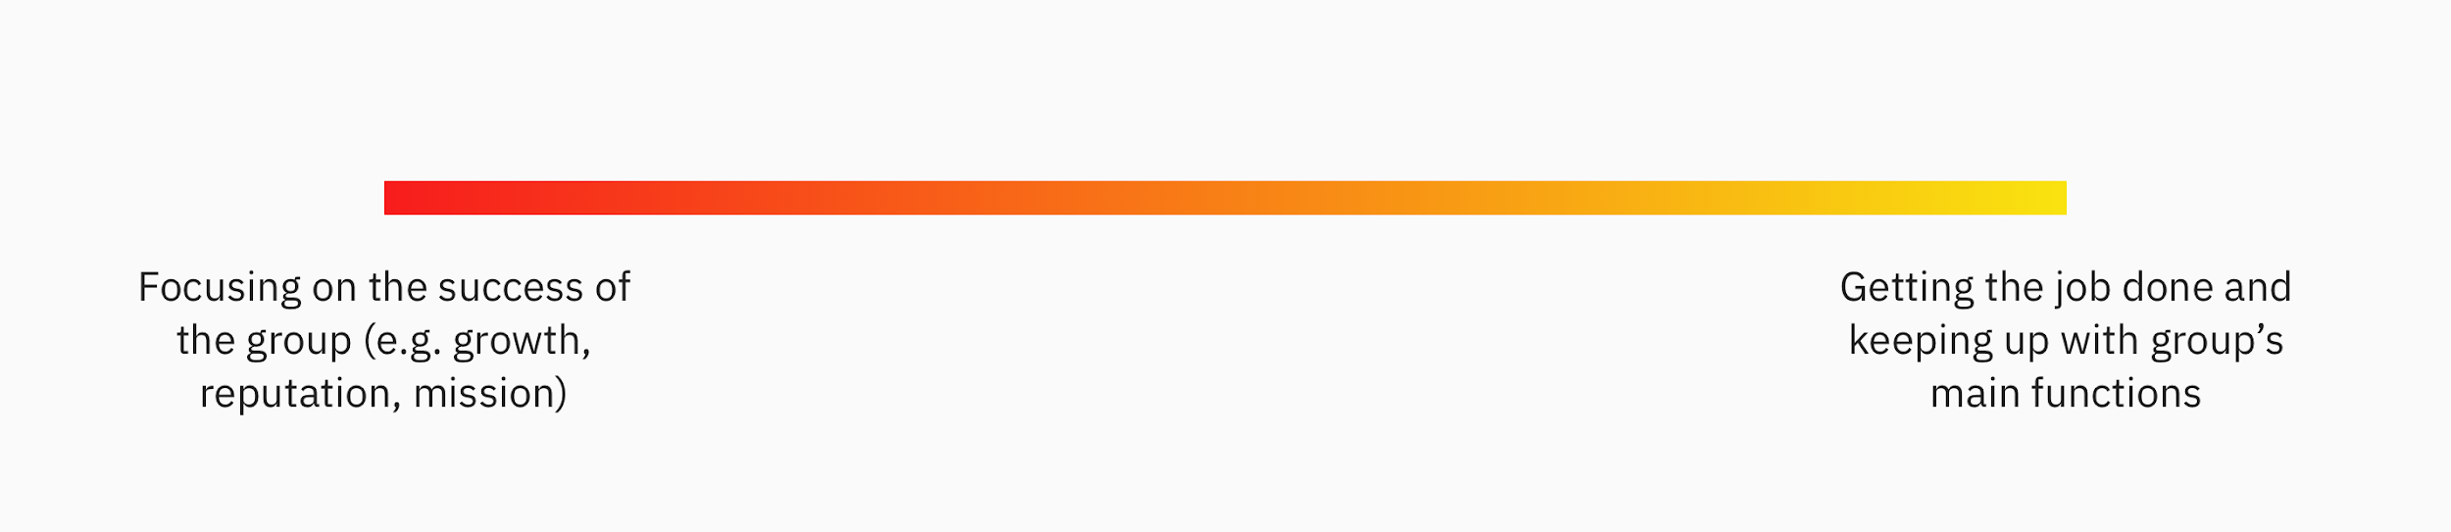

The leadership motivation spectrum

Leaders had motivations that lied somewhere on the spectrum above. We saw that this was not merely about self-motivation, but often about the efforts and function of the organization. This is because:

* Small interest groups (e.g. Club Baseball, Physics association, Cultural organizations) mainly exist to serve its own members -> Growth is not a priority for leaders
* While professional/performance groups are concerned with impact/presence on campus -> Success/growth is a priority

This is an important point. Agnes needs to prioritize group leaders who are not simply concerned with doing the bare minimum to keep their group afloat. Instead, we should focus our efforts on these **groups that are concerned with impact or presence on campus** as they are most likely to consider different methods to increase engagement.

In the end we boiled down our first round of research into a consistent interest in two things:

1. Finding and growing an audience

2. Engaging their audience to keep them active

With a good sense of the ideal target audience AND their main concerns in terms of campus engagement, our next goal was to bring more focus to a value-driven solution.

## Narrowing down the idea

To start, we wanted to get a clearer picture of what group leaders are currently using to spread information about their group and engage with their audience.

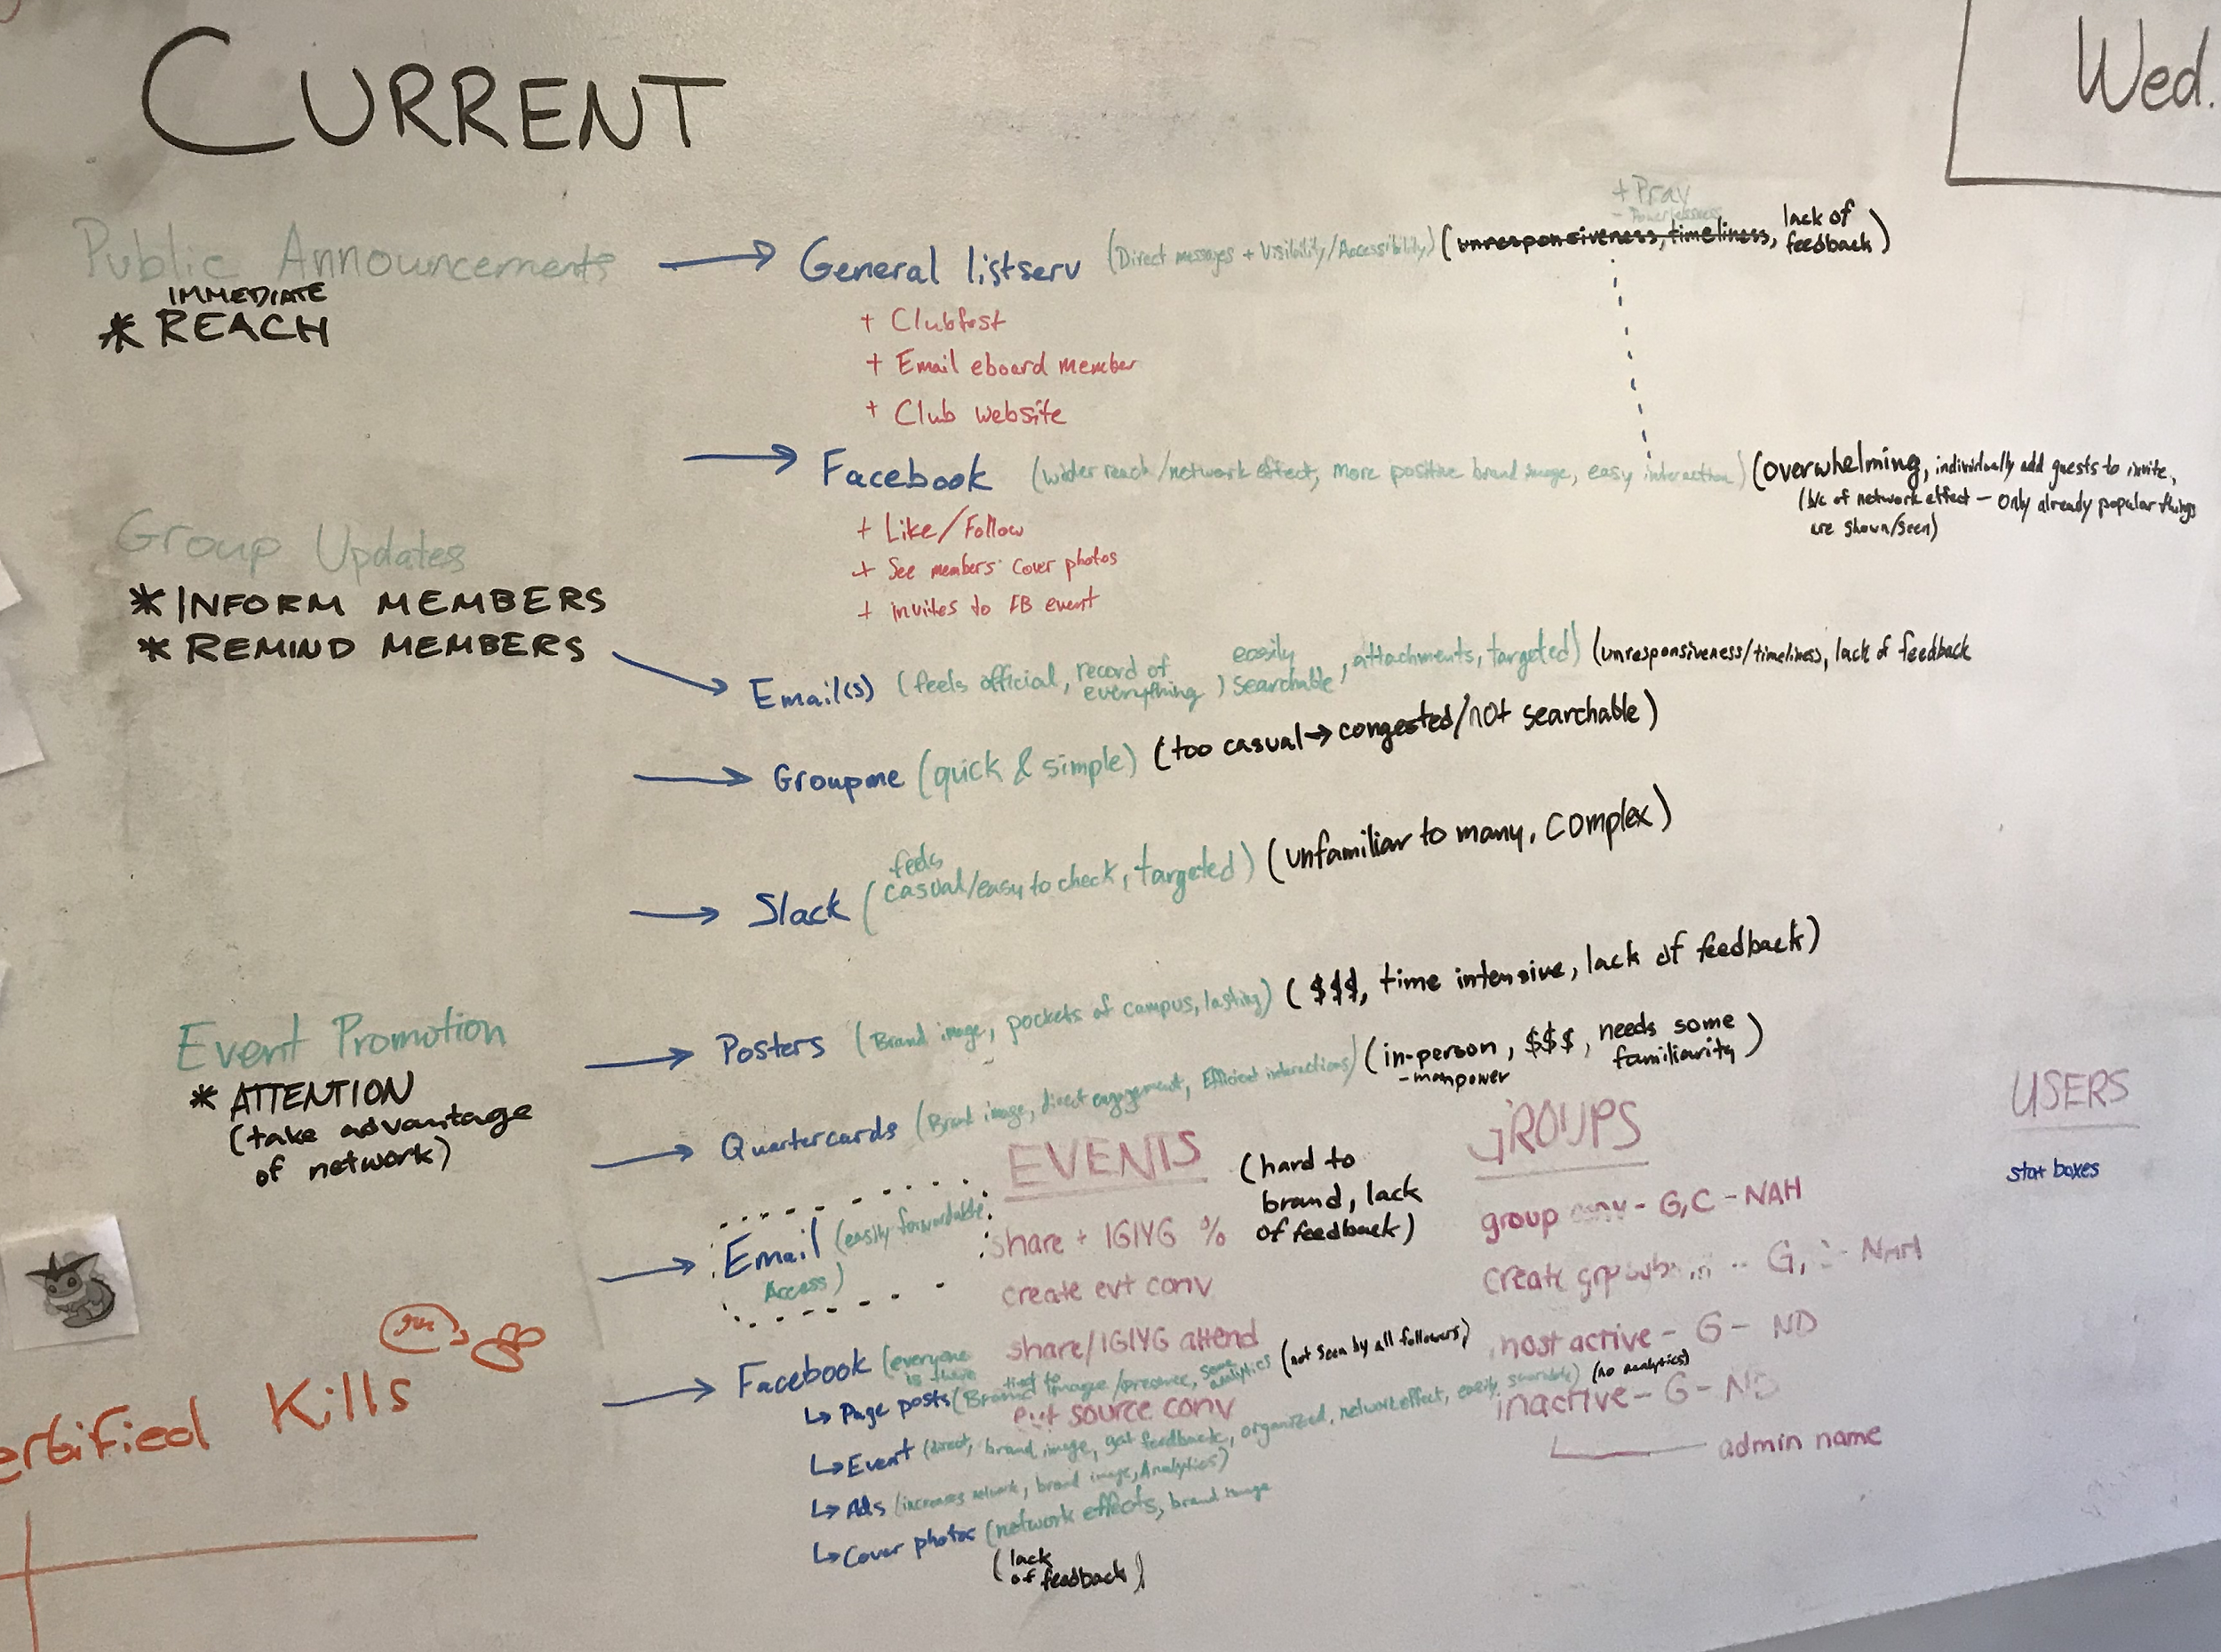

Breaking down how leaders currently solve their problems

Above, we identify types of information to be shared - Public Announcements, Group Updates, Event Promotion - and reason in green and black on the far left side, the specific tools used to share this information is in blue, tool’s positives in green, and tool’s negatives in black. We started to realize that lack of feedback was a trend in newer tools and might be a big area of opportunity. Knowing if someone is seeing your messages, whether sharing updates or promoting events was explicitly mentioned as important to some the groups we talked to. Therefore, especially among a campus where a large majority of clubs still use email for event promotion, we thought this could be our low-hanging fruit to significantly advance the email experience for student leaders.

Initially, we decided to make the experience an entirely in-email tool for leaders to share events, thinking this would be the lowest barrier to entry; if people are using email, an in-email form would keep them in their email client. However, this did not turn out to be feasible within a quick time frame due to security measures in an email itself. We landed back on the web interface, this time with an emphasis on not only events but any email announcement as well.

This brought us into the territory of **listservs** and **evites** and trying to take what people are already attempting to do with emails and keeping it as simple, beautiful, and straight forward as possible. However, given the timeframe, we could only build an MVP easy enough to build in about a month. No small task.

In summary, the thinking is that a beautiful, interactive email interface along with analytics for any message sent to their team could create value for leaders who are concerned with reach and engagement.

## User testing the idea + market research

Before designing this event promotion/listserv replacement, We talked to **3 of the previously interviewed leaders**(the President of ISU, President of CBA, and President of Society of Physics students - they were easiest to contact)and **4 new student leaders** (President of Chinese Student Association, Internal Outreach for ISU, former President of Cornell Finance Club, and a CUSD project leader) to get a sense of how useful this might be. We ran into two main problems in their feedback:

* Feedback 1: “I just want to reach people”
* Analysis 1: High impact groups on campus **want to reach as many people as possible**, but Agnes is unable to support the numbers they want *for now*. We simply don’t yet offer a larger user base than anything else that would be used.
* Feedback 2: I’m confused. “What are you doing?” And: “Why would I want to put my events here?”
* Analysis 2: Leaders are also unsure of how this benefits them/makes things easier
  + If wide reach cannot be offered for now, how else can this product provide value? How can this fit into their workflow?

Before these users take the time to share their events through Agnes as a standalone platform, they want to ensure that their efforts with us will reach a lot of people. How do we approach this if we can’t offer that immediately as the school year starts?

One assumption is that a separate product (framed as “powered by Agnes”) could provide more value if it **focused on making the email promotion process easier**, instead of event creation and management on the Agnes platform with email capabilities. We began mocking up some early thoughts and showing students visuals:

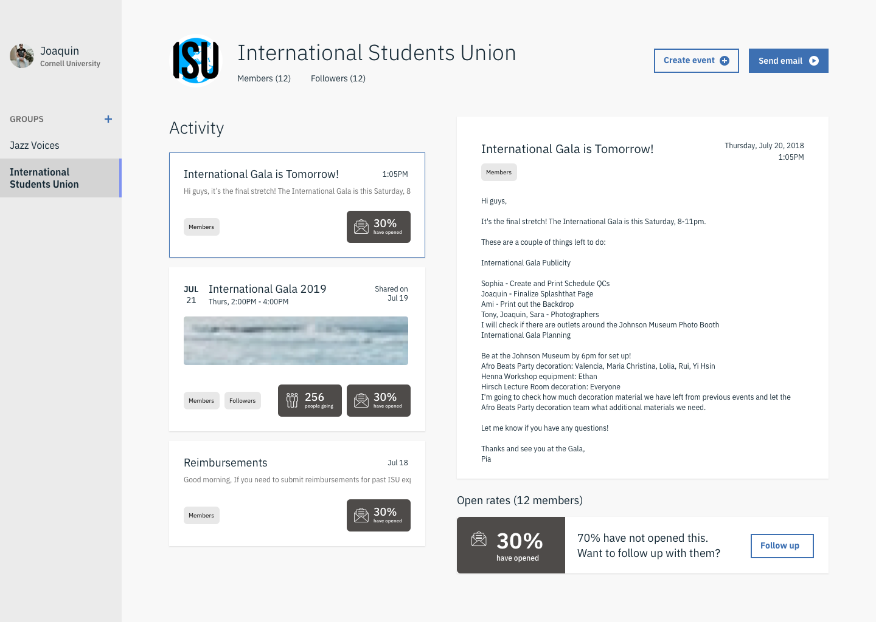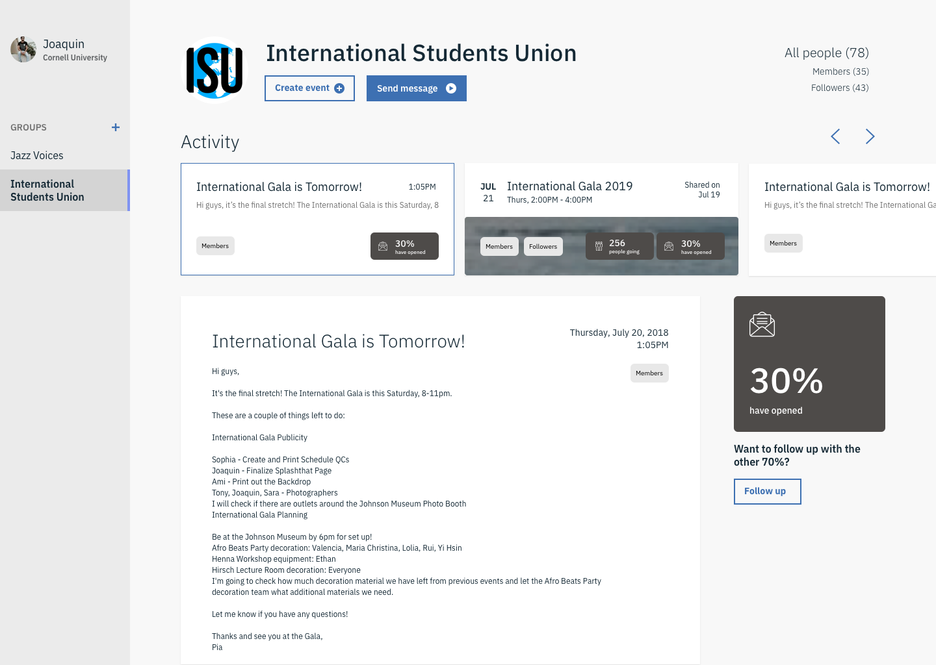

Initial explorations of this promotion tool.

For this process, I would 1. first show them the mocks and generally ask them if it’s clear what they are supposed to do and then 2. talk them through what they can do and see what the feedback was.

Unfortunately, I still ran into the problem of product focus. Feedback:

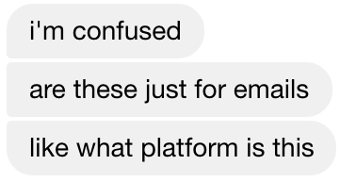

Initial impressions on the mocks before explaining

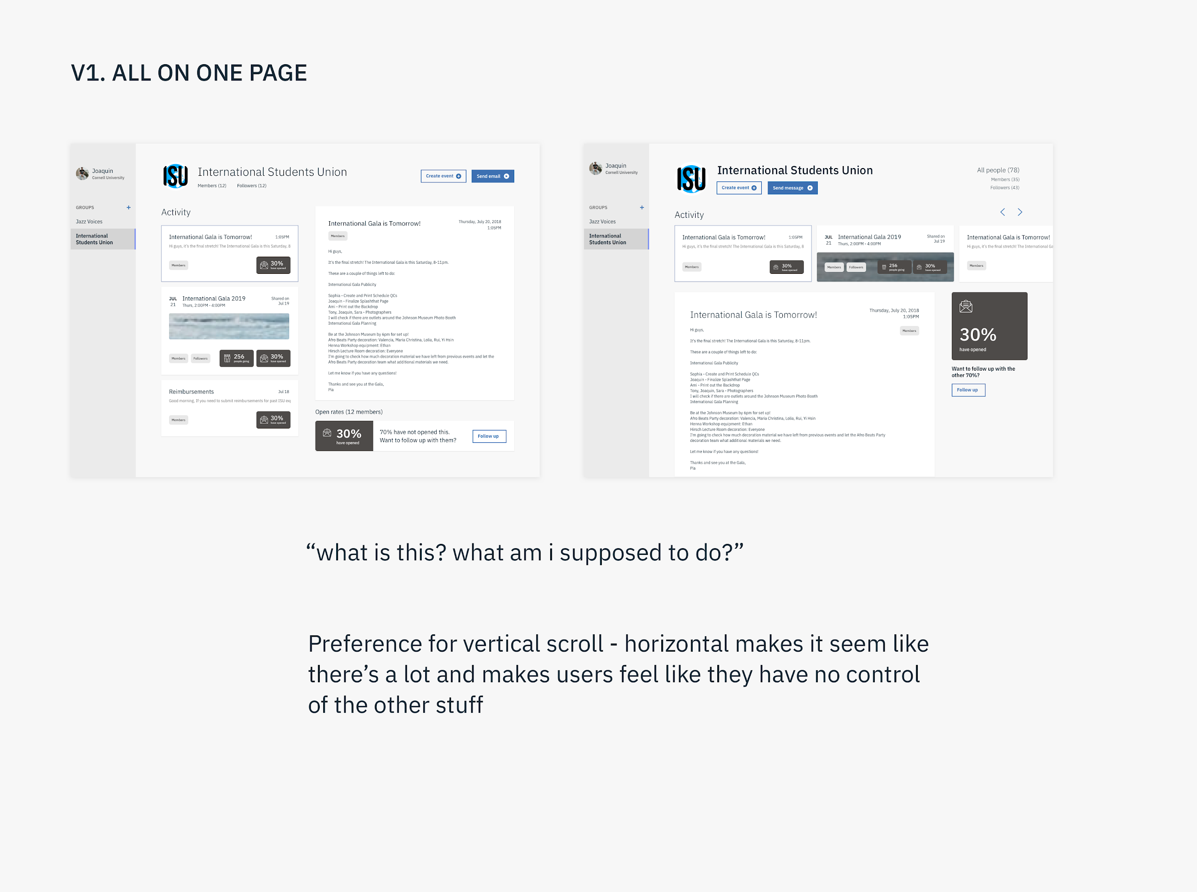

To address these issues, I continued exploring different designs and going back to these 7 leaders for feedback as we assembled new designs. The iterations and feedback were as follows:

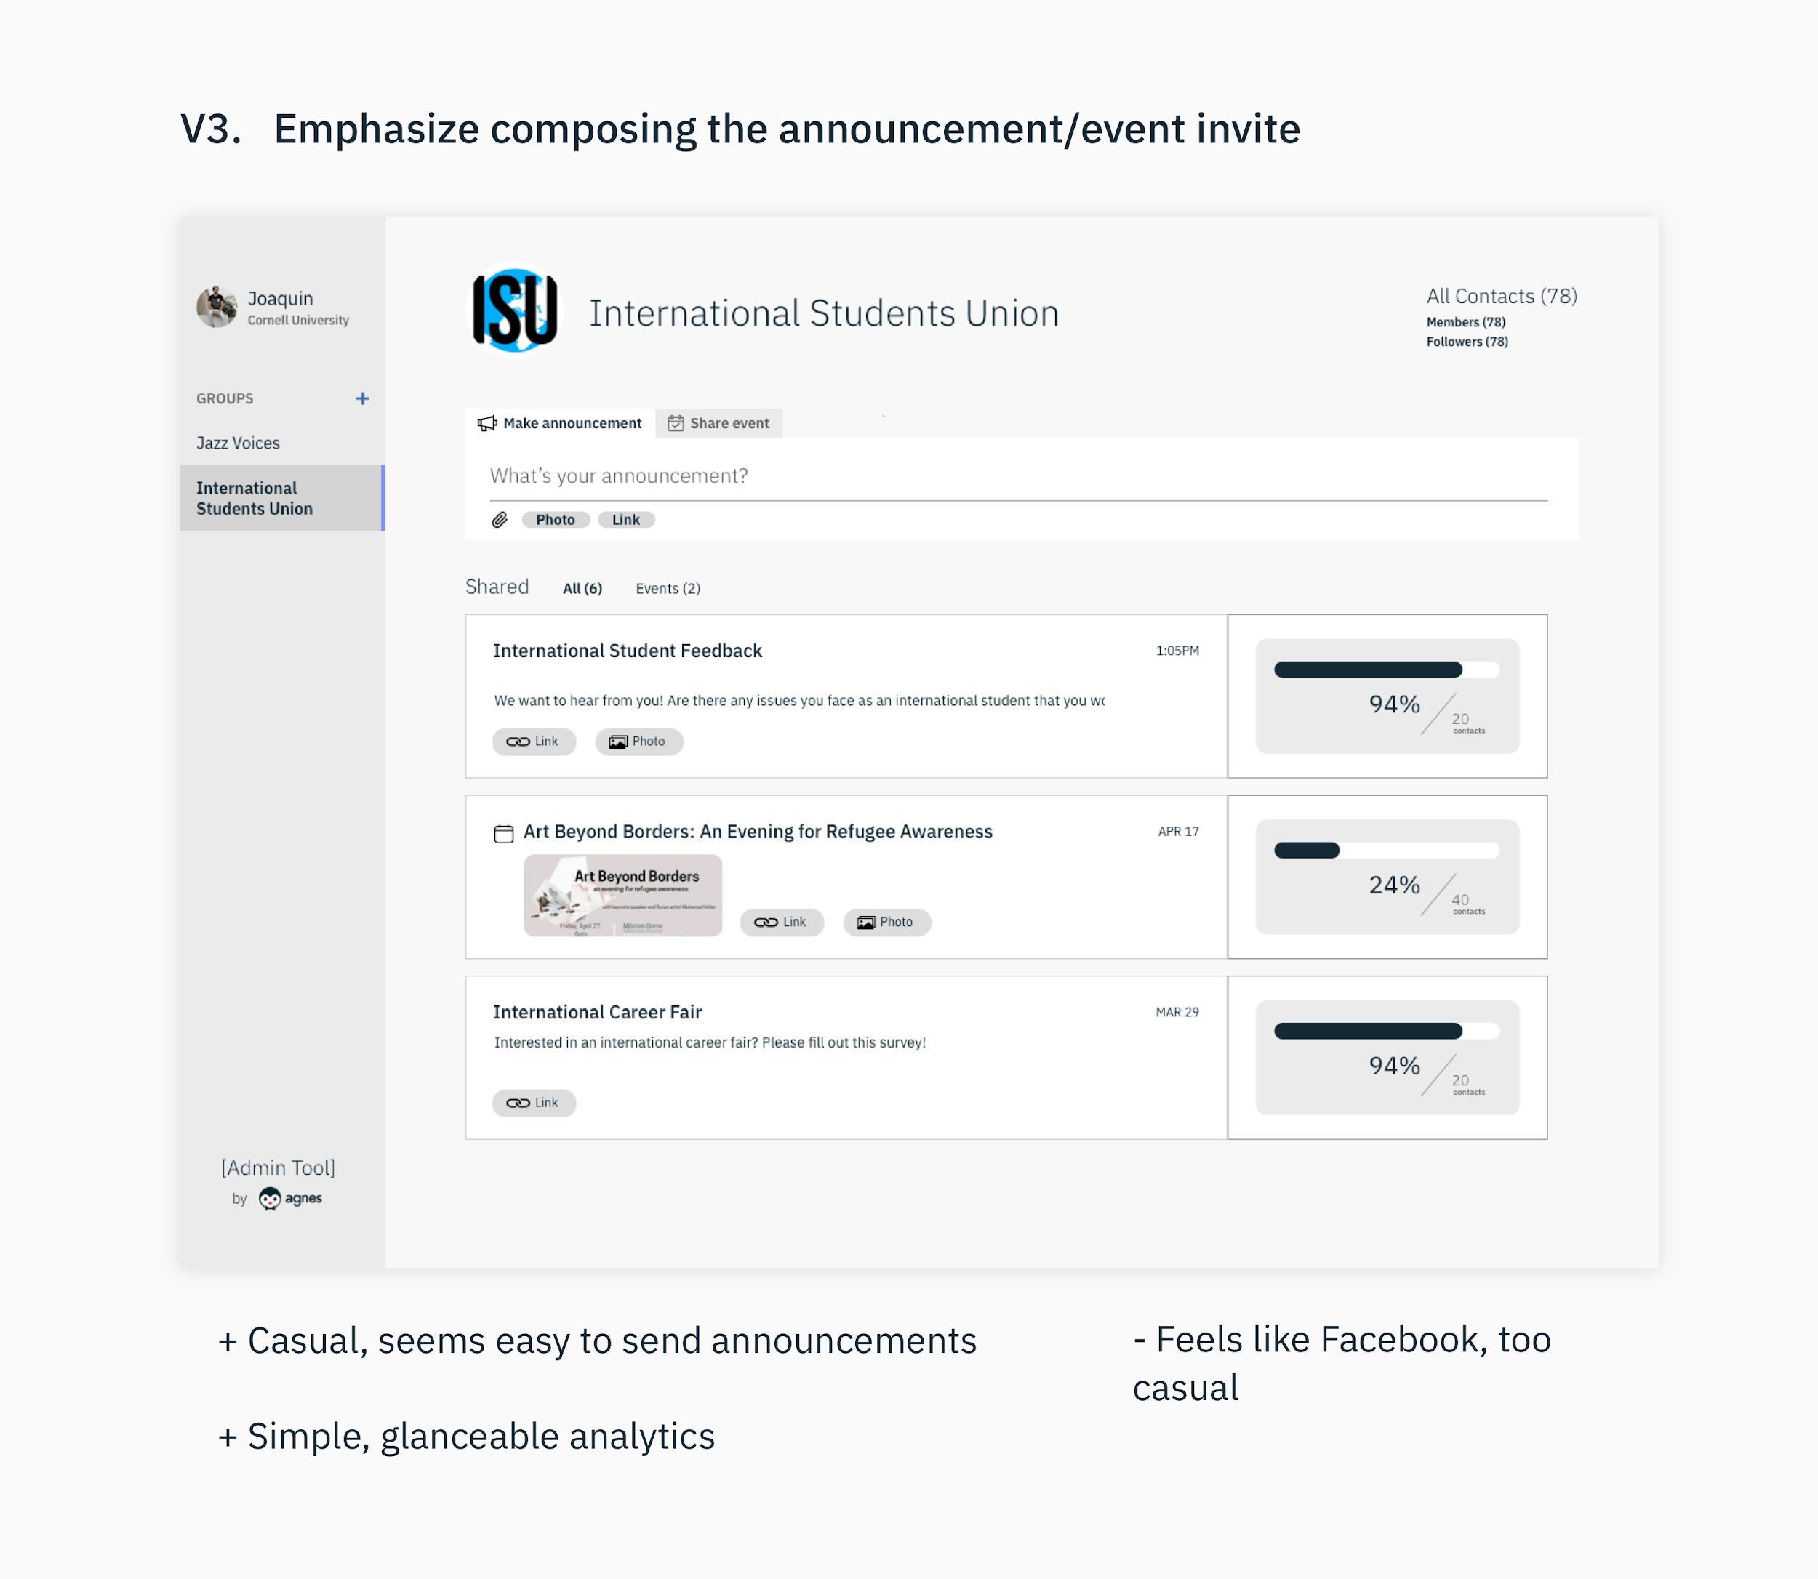

(Bullet points are positive (+) and negative (-) feedback)

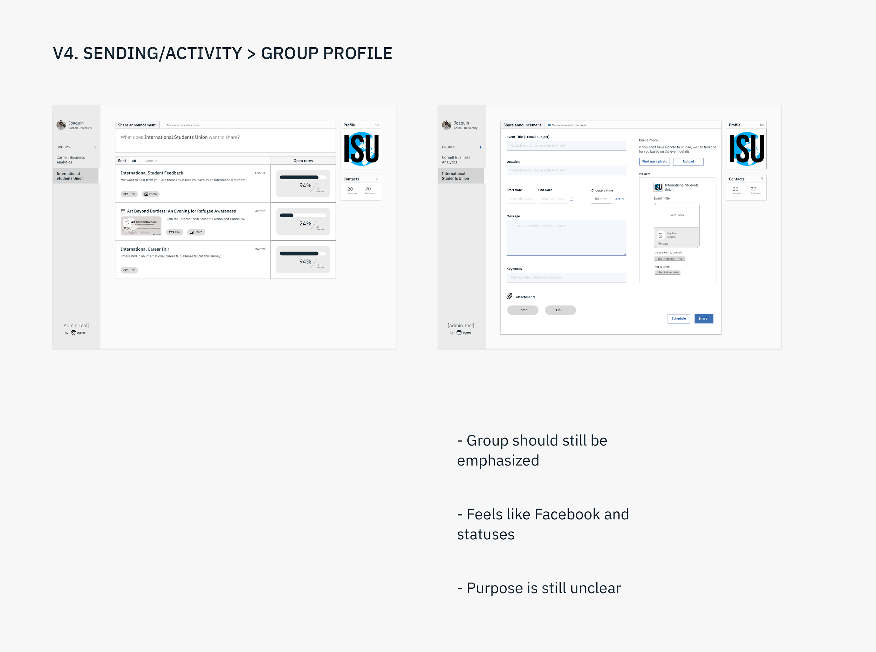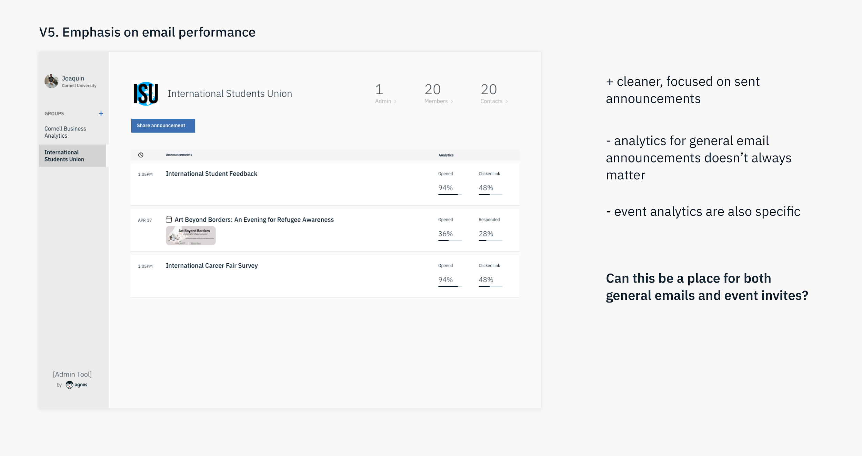

“Event analytics are also specific” means that the analytics someone would want for event promotion differs from those of a general announcement.

There was still general confusion over being focused on general announcement emails and event invites. To address this, I looked into both listservs and event invitation platforms to get a sense of how they are used:

* Listservs are used by many groups, but students themselves aren’t very engaged
  + Too multipurpose - groups make announcements for all sorts of things -> Should the product try to tackle all these use cases? Or can it be more simple and focused?
  + Problems with listservs often seem to have to do with *management* of the list - How many of these people need to receive the emails (segmentation could be easier)? How many of them actually read the message?
  + Since listservs are very difficult to track, leaders feel like they’re just shouting into the wind. So we asked ourselves:
    - Would addressing this problem lead us to a product focused on management? Does tracking email opens/responses/engagement change anything?
* Evites are highly specific - What types of events need a beautiful invite? Having a nice template only comes into play *sometimes*
  + Should we focus on these specific cases?
  + *This is perhaps the next thing to do more research on* - how often are these used currently? For what kinds of events? What user spectrum exists here and what part of the spectrum do we want to target?

## Focusing on event promotion

In trying to design a simple, cohesive product, I thought it best to get rid of email announcements. Focusing on making event promotion easier might make more sense to student leaders.

Initially, I thought since everyone already uses Facebook (almost automatically) when they have an event, what if the product was focused around making it smooth and easy to share those events via email?

However, guidance from Kai and the rest of the team made me see how this was bad product thinking in the long term. Agnes shouldn’t merely be an accessory to Facebook. Agnes takes precedence, even if the product isn’t necessarily an Agnes web version. There needs to be a balance of ease with what people are already doing and a sense of autonomy for our product ecosystem.

We started drawing up what the experience on this tool could look like from the get go:

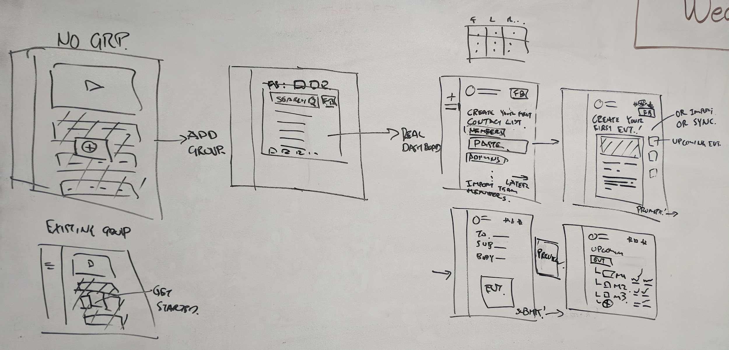

Main onboarding flow by Kai

Left side: User comes in, experiences an instructional video, and sets up their group (whether it exists in our database already or they have to add a new one). Right side: adding group members, still make “create event” a thing on Agnes, and event email composing + getting analytics.

However, running the idea of pulling from Facebook started to get positive feedback.

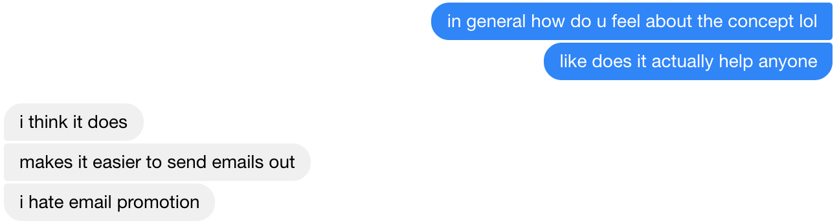

“As a student leader, does this help?”  
(“I hate email promotion” was in the context of having to write out an event email, which feels slow, can often have mistakes, competes with so many emails already, and provides no feedback on how useful it actually is.)

With all this in mind, we made our next iteration:

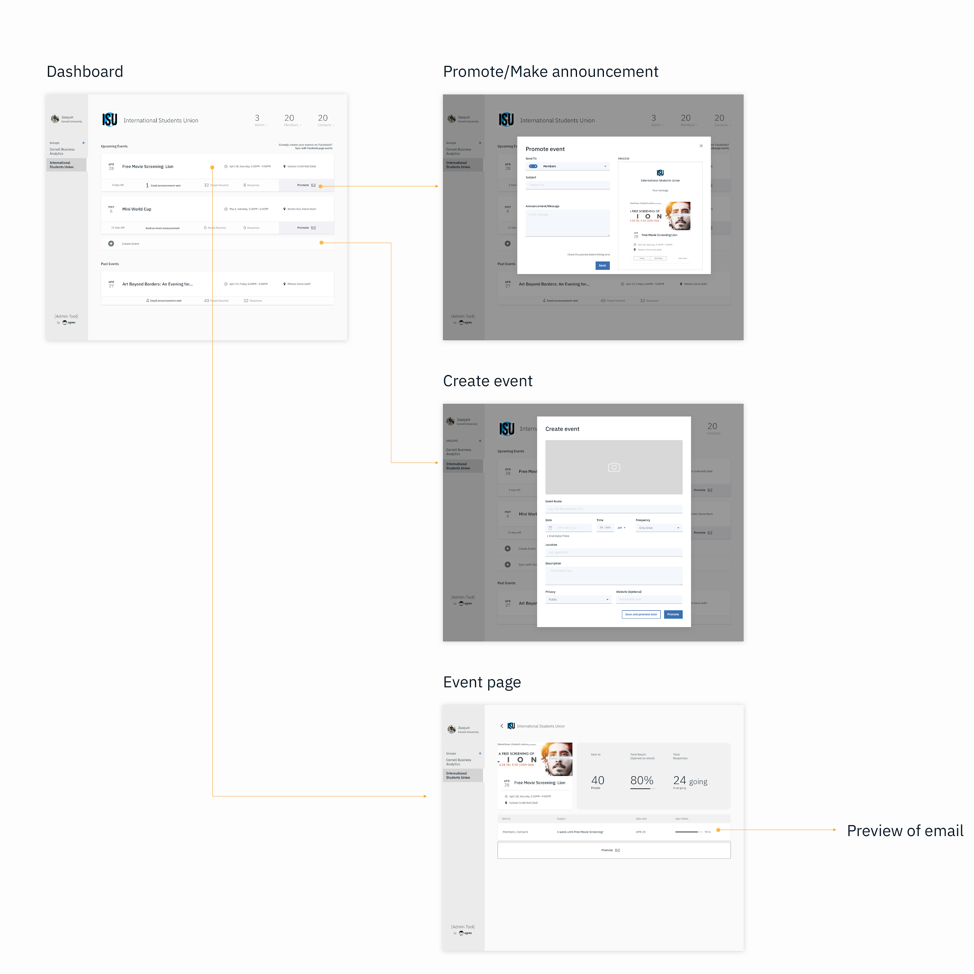

Initial exploration of main flow

These explorations (designs incorporating info pulled from FB) finally started getting more positive feedback due to clarity and easy of workflow. They’re going to put it on FB anyway and probably send out an email as well.

## Evaluation, future considerations

Revisiting our likely target audience, there’s a good chance that the actual product user falls somewhere in between the two previously defined ends of the leadership motivation spectrum. The highest impact events also don’t happen frequently, so maybe the focus should be groups in between informal interest clubs and clubs that hold one huge event each semester or year - like TEDx or a hackathon. Perhaps it’s the professional clubs that hold weekly talks and want to know how their promotions and in-person engagement are faring over time - these groups may be the main beneficiary of the event email promotion tool.

In the meantime, one especially useful characteristic about this product is that it can fully stand alone. You don’t need the app to create an account as a leader nor do you need the app to receive emails and be engaged as a group member. This creates a huge opportunity if we can get the formula correct for this tool by allowing us to reach anyone with an email address while also building up content (events) in our database, which we can push into the app.

As we begin piloting the beta version of this tool, more research should be considered on the kinds of groups that would be using this, what kinds of events they use it for (small weekly events, or big infrequent events), and how often they host these kinds of events. As we press on, one of the areas of improvement that is likely to need more attention is how to provide more analytics/data back to the group leaders and how to make it as actionable as possible.

## Appendix

It is worth noting that in hindsight questions skewed in focus toward clubs’ external efforts (interactions with the wider campus beyond the group). We believe this happened due to the combination of two reasons, which we explore below.

First, we found the internal operations to be centered around internal group communication, which is a crowded space. Groups use some combination of email, slack, groupme, fb messenger, and texting which overall vary in only small ways. We did not find that one dominated the space over the others but also didn’t think that was a space that we wanted to compete in. Meanwhile, other internal operations included: submitting for registration and budgeting, managing a recruiting process, and organizing to-dos for their members. However, we didn’t find any of these issues to be both simple and common for any significant number of groups that we talked with.

Second, we have always thought of Agnes as a tool that supports the connection of opportunities between people within a community and assumed that the external connections was where the biggest opportunities were for Agnes.